Nanotechnology

Tutorial 1

Susmit Walve (19311020)

**Q1) For each area below, present and describe at least one application of nanoscience. Describe also which basic areas of scientific knowledge this application requires.**

1. **Medicine**: Nanodevices can make gene sequencing very efficient. Gene sequencing is a method used to determine the order of the bases inside a DNA molecule. Using nanotechnology, it will be possible to identify the specific genetic makeup, revolutionising the specificity of diagnostics and therapeutics. Health care will become less expensive by the usage of in-vivo devices. Improved drug delivery can be achieved, which leads to optimal drug usage, i.e. when the medicine is correctly transported to the affected part, there will be less drug wastage. A cancer diagnosis can be made using a nanotube-based biosensor. This will lead to early detection and prevention of diseases.
   1. Area of Science used
      1. *Physics*: Quantum Mechanics and Classical Mechanics is required to predict how the nanoparticle will move inside the body in case of in vivo devices and drug delivery.
      2. *Chemistry*: Organic Chemistry is required to understand how the nanoparticle will react to the surrounding body chemicals. Chemical Kinetics and Quantum Chemistry are also required to ensure that the drug doesn’t get released before reaching the affected portion.
      3. *Biology*: It is important to know Biochemistry, Biomechanics and Biophysics to understand how the drug will be carried to the affected portion.

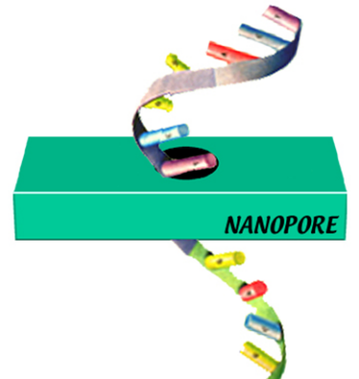 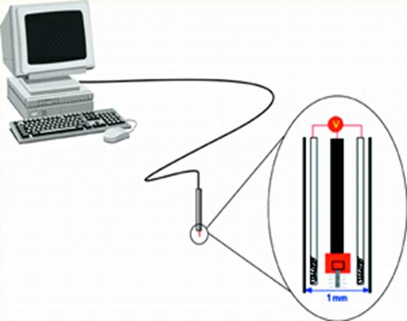

1. **Energy**: It is possible to construct materials that change according to the surrounding conditions and alter their inner structure. It is possible to make solar energy collectors with high flexibility, heat-absorbing windows, energy coatings and Nano-insulations. The flexible insulation allowed the panels to be thin enough to fit within the existing window casements without modifying window and roof fixtures. This will lead to saving energy during extreme weather conditions.
   1. Area of Science used
      1. *Physics*: Electromagnetism, quantum physics and solid-state physics will be required to understand how the material will be affected by irradiation.
      2. *Chemistry*: Thermodynamics will be required to evaluate the heat absorption and other temperature-related properties of the material.
      3. *Materials Science*: This will be required to evaluate which material will be best for our needs.
      4. *Engineering*: Micro-fabrication techniques will be required for designing the final product. Systems engineering will also be required to ensure proper merging together of the various technologies used.
2. **Electronics**: With nanotechnology, it is possible to design processors with declining energy use and cost per gate, thus increasing computer efficiency by 106. While transmitting data, it is possible to provide ten times the current bandwidth by efficiently utilising the optical spectrum. Also, it is getting possible to store large amounts of data in smaller volumes. Integrated nanosensors can be used for collecting, processing and communicating massive amounts of data with minimal size, weight and power consumption.
   1. Area of Science used
      1. *Physics*: Quantum Mechanics will be required to understand how the materials which are storing data work at such a small scale.
      2. *Math*: We will need to work with how the data can be read and written in the material.
      3. *Engineering*: Electronic circuit design and Microfabrication will be used to design the data storage device and other nanosensors.
3. **Sports**: To prevent fogging of sports glasses it is possible to apply an additional layer over them. Fouling is the accumulation of unwanted materials on the surface of ships. Anti-fouling coating can be made using nanotechnology. Carbon fibre technology is also used in making lightweight and stronger rackets and cycles.
   1. Area of Science used
      1. *Computer Science*: We will need to ensure that the sports equipment is able to endure the forces which will be applied to it.
      2. *Engineering*: Preparation of the nanotechnology-based material and manufacturing of the equipment requires engineering technologies.
      3. *Material Science*: The properties of the materials will be explained by material science.



**Q2)** **Describe quantum dots and their use in various areas.**

Quantum dots are semiconductor particles of nanometer size which show the size and composition-dependent optical and electronic properties.

Applications:

1. Quantum-dot lasers: As the dimension is lowered, the modified density of states concentrates carriers in a certain energy range. This concentration is expected to give the system more gain for lasing. Zero-dimensional quantum confinement of carriers converts the density of states to a set of discrete quantum levels. For lasers, we need monochromatic output and hence such discrete levels are very advantageous.
2. Bioimaging: Earlier, Organic dyes were used for bioimaging. But these dyes suffer from low quantum yield and photostability. QDs are 20 times brighter and 100 times more stable more than traditional fluorescent reporters.
3. Photovoltaic devices: Since quantum dots have tunable band gap, they have perfect properties for photovoltaic devices. QDs have the potential to boost the efficiency of silicon photovoltaic cells and lead to reduced costs.
4. Optical data storage: Quantum dots may be appropriate for data storage because quantum dots have a different size in various media leading to broadened absorption spectra.

**Explain in particular their optical properties and how these can be modified.**

Semiconductors change their bandgap with a change in size. As quantum dots can range from 30 to 200 eV, the entire visible spectrum can be covered. The energy bandgap increases from 1.8 eV on bulk materials to almost 4 eV at the 30-nm size of quantum dots, which leads to a wide range of light-emitting and –absorbing spectra.

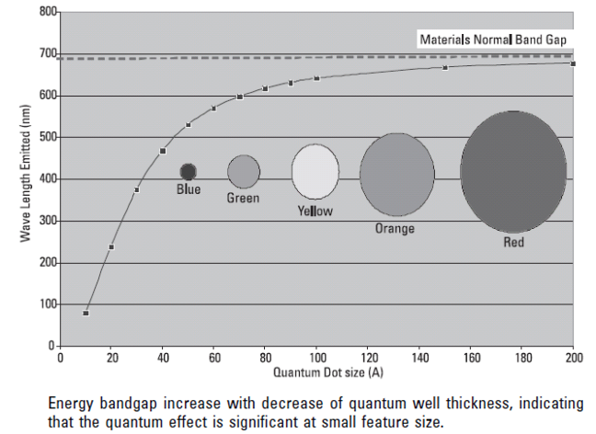

**Q3)** **Show in detail using a simple quantum mechanical calculation how the optical properties can be changed. Approximate the quantum dot in a suitable way and simplify by only studying the one-dimensional case.**

$$ⅈℏ\frac{∂Ψ(x,t)}{∂t}=\frac{-ℏ^{2}}{2m}\frac{∂^{2}Ψ(x,t)}{∂x^{2}}+V(x) Ψ(x,t)$$

Suppose the wavefunction can be written as $Ψ\left(x,t\right)=ψ\left(x\right)T(t)$

$$ⅈℏψ\frac{∂T}{∂t}=\frac{-ℏ^{2}T}{2m}\frac{∂^{2}ψ}{∂x^{2}}+V\left(x\right)ψ\left(x\right)T(t)$$

$$ⅈℏ\frac{1}{T}\frac{∂T}{∂t}=\frac{-ℏ^{2}}{2m}\frac{1}{ψ}\frac{∂^{2}ψ}{∂x^{2}}+V\left(x\right)$$

Since the RHS is completely dependant on x and LHS on t we can say that

$RHS=LHS=E_{n}$ where En is a constant.

Suppose $V\left(x\right)=0 ;0<x<L$

$=∞ ;L<x<∞ \&-∞<x<0$

When V= $∞$ the wavefunction will be zero

When V=0

$$\frac{-ℏ^{2}}{2m}\frac{∂^{2}ψ}{∂x^{2}}=E_{n}ψ …(1)$$

The solution for this ODE is

$$Ψ=A\cos{αx}+B\sin{βx}$$

The wavefunction should be continuous at the boundary. Since 🡪 A=0

Also 🡪

Substituting this in Equation (1)

$$\frac{ℏ^{2}n^{2}π^{2}}{2mL^{2}}=E_{n}$$

$$E_{n}=\frac{n^{2}h^{2}}{8mL^{2}}$$

$$ΔE=E_{2}-E_{1}=\frac{3h^{2}}{8mL^{2}}$$

Now if we calculate this value for some different values of L=1 m,1 mm, 1µm, 1 nm

$$ΔE\left(L=1m\right)=1.13 × {10}^{-18}eV$$

$$ΔE\left(L=1mm\right)=1.13 × {10}^{-12}eV$$

$$ΔE\left(L=1μm\right)=1.13 × {10}^{-6}eV$$

$$ΔE\left(L=1nm\right)=1.13 eV$$

**Q4)** **Synthesis of nanostructures involves basically two different types of methods: top-down or bottom-up.**

**a) Describe these two methods and show with examples how they work**

1. Top-down 🡪 This approach involves starting from a bulk material and designing it into nanoparticles. The main approach of this approach is the removal of bulk material to produce the desired structure with appropriate properties. This can be done using short-wavelength optical sources. This is known as *Optical Lithography*. It can in general allow refinement up to 10 nm. For even more accurate patterns, electron beam lithography can be used. There are multiple processes to work with top-down approach
   1. *Mechanical Methods:* Some methods are cutting, etching, grinding and ball milling.
   2. *Lithographic methods:* Some such methods are Photo-lithography and electron beam lithography

*Example:* Nanosphere Lithography Technique

1. Clean the surface of the substrate.
2. Drop the nanosphere solution on the surface.
3. Let the solution dry off.
4. Now deposit the metal on the substrate.
5. Remove the Nanospheres

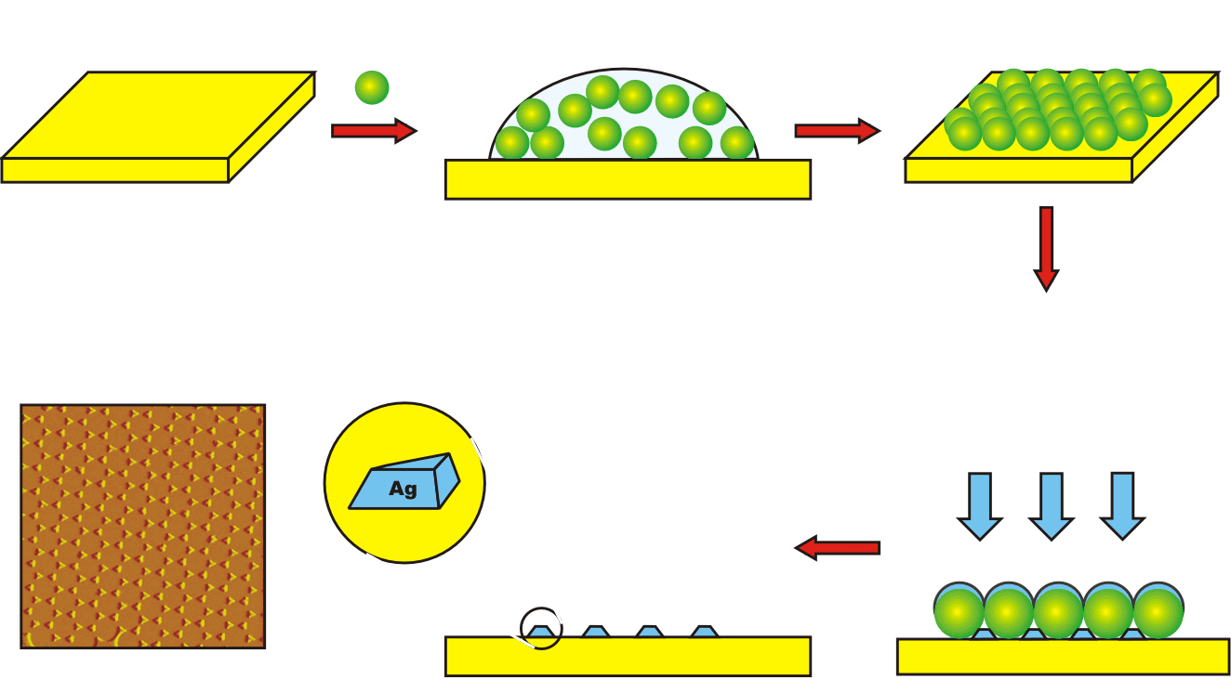

1. Bottom-up Approach🡪 This method involves building up whatever we want by assembling from small prefabricated units such as atoms and molecules. Atom by atom deposition leads to formation of self-assembly of atoms/molecules. There are multiple methods to implement this approach
   1. Physical techniques
      1. Physical Vapor Deposition: Condense the vapor phase species on the required surface
   2. Chemical techniques
      1. Deposition of vapor phase of reaction species
      2. Self-Assembled Monolayer: Electrolytic deposition, sol-gel method, pyrolysis

Example: Evaporation technique

* Thermal evaporation
  1. The material to be deposited is kept inside a boat facing the substrate.
  2. A high current flowing through the boat heats it up and causes evaporation of the material.
  3. This evaporated material is deposited on the substrate when it condenses.

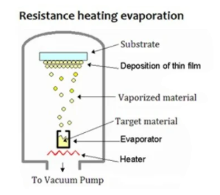

* Electron Beam evaporation
  1. High energy electron beam is bombarded on the material to be deposited.
  2. High DC voltage is applied to a tungsten filament to generated electrons.
  3. These emitted electrons are accelerated to the target solid.

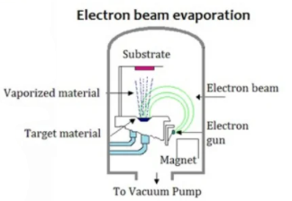

**Which differences in nanosystem properties may these two methods give?**

The nanoparticles generated by using top-down approach contain stresses, defects and imperfections which get introduced. For example, nanowires made by lithography are not smooth and may contain a lot of impurities and structural defects on its surface. Such imperfections would have a significant impact on the physical and chemical properties of nanostructures and nanomaterials. Also, there is less control over the deposition.

**For which type of system is one method more suitable than the other?**

Top-down approach is used when large scale production is required. This is so because it is possible to deposit on large amount of substrate. Also, chemical purification is not required. Bottom-up approach is used when we want smaller sized distribution. Using this method, it is possible to make Ultra-fine nanoparticles, nano shells and nanotubes. The deposition parameters can be controlled thus leading to accurate final product. This method leads to lesser wastage and hence is also more economical.